LAB 8
HEMACHANDAR P
255HSBD010
(1) Open the data file using the VIM editor.
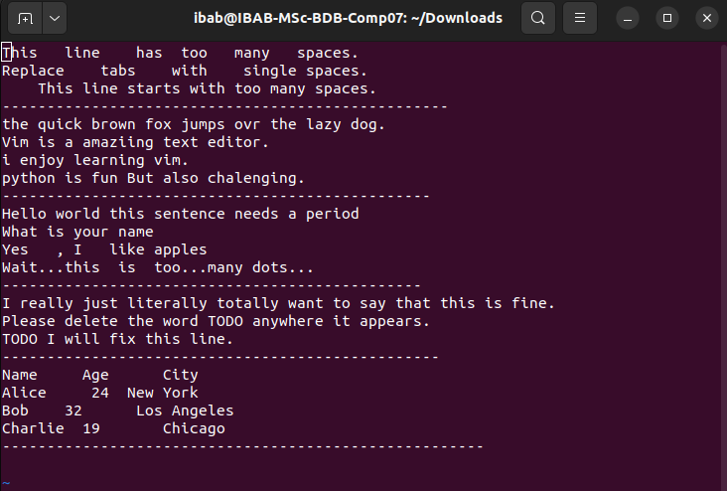
2) Move to the beginning of the file and insert the text: ”VIM challenge begins!” on a new
line at the very top
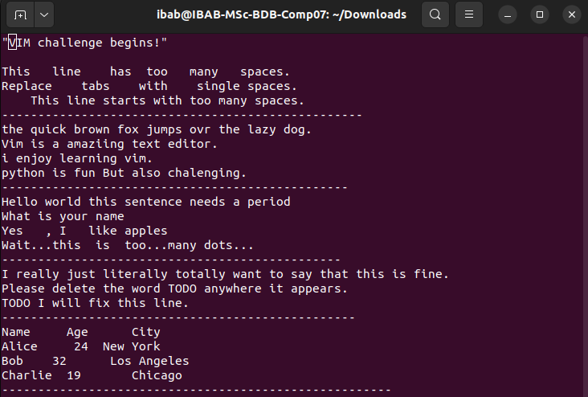

3) Find the word ‘Meningioma’ and replace it with ‘LG glioma

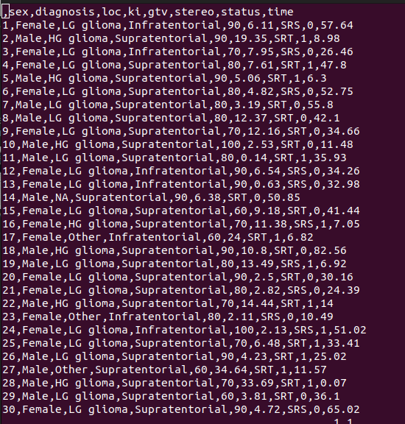

(4) Delete the entire line containing the time column entry ‘34.66

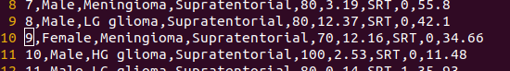

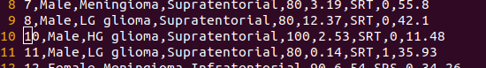

(5)Copy the current line and paste it two lines below. Show the screenshot before and after
pasting with file line numbers to prove that you did it correctl

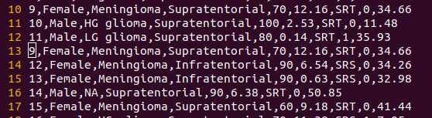

(6)Move to the 11th line of this file and insert ”Hello from line 11!”

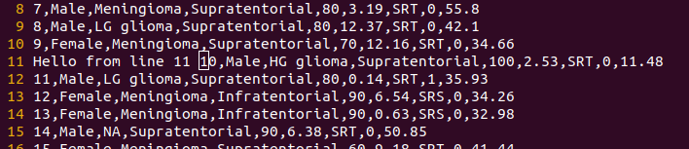

7) Search for the word ‘SRT’ and replace it with ‘SRS’ (all occurences in the file)

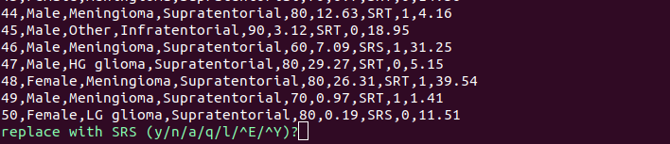

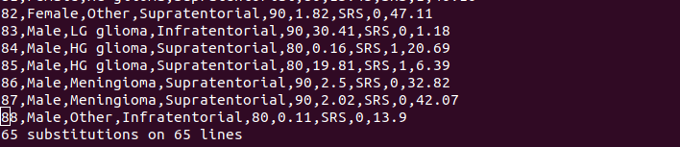
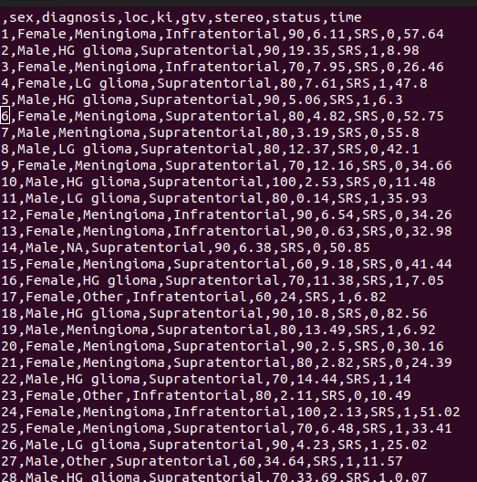

(8)Yank the first 3 lines of the file and paste them at the bottom
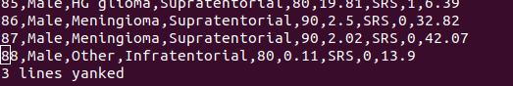
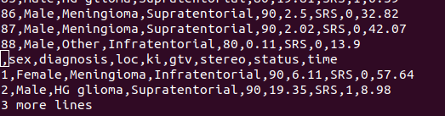

(9)Visually select this entire instructions list and indent it by two spaces.
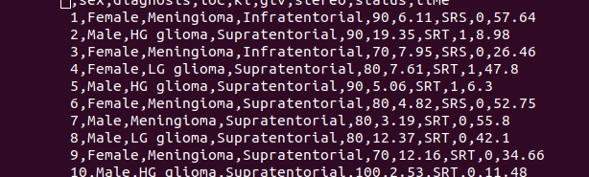

(10)Go to the 50th line number, and insert the following text: “ The cat sat on the mat.
Another cat was watching. The cat did not move.” Replace all occurences of the word
“cat” with ”tiger”.
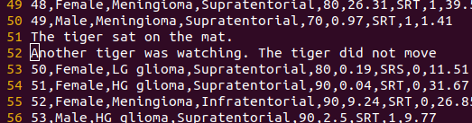

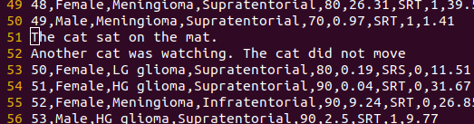

(11) Insert the text “This is an important reminder for you.” at 70th line number. Then
change the word ‘important’ to ‘critical’. Describe the sequence of keystrokes used in
full.
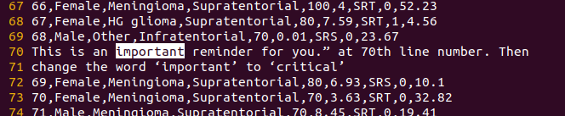
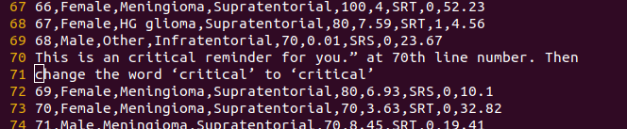
:70,71-here we are saying that line no 70 and 71
:70,71s-here s menas substitute or otherwise we can use shift +r
:70,71S/important/critical-here instead of importanty we are substituing critical in the place of important in the line 70 and 71

12) Note down the current line number, jump to the end of the file and jump back to this
line without scrolling through every line. Describe the sequence of keystrokes used in
full


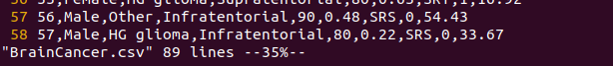

by pressing G we can go the last line
:37 and enter , it will go the same line again

13)Add the following sentence at the end of the file: ”The quick brown fox (who was very
quick) jumps over the lazy dog.” Delete the text inside the parentheses (including the
parentheses) in the following text. Describe the sequence of keystrokes used in full.
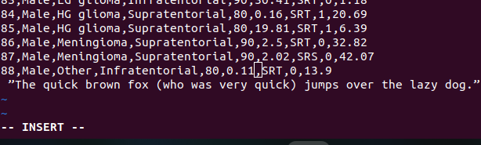
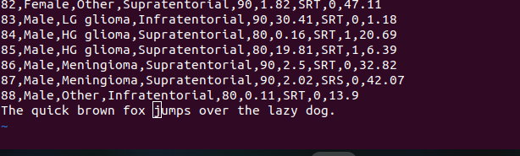
%s/who was very quick/ (space)

14)Go to the last line of the file and append: ”– end of challenge”

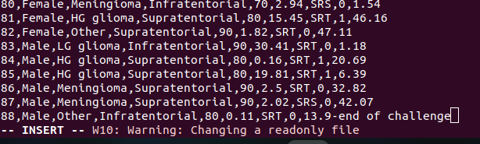

15) In the remaining exercises, we are going to use Vim’s search, replace, visual modes and
text objects. Open the file vim_cleanup_exercises.txt and do the following. Describe
the sequence of keystrokes fully for each problem.
(i) Fix spacing issues in the text in the lines 1-3.
here i have substituted three spaces with single space
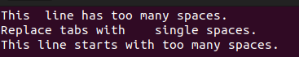

(ii) Fix any capitalization and typographical errors in lines 5-8.
here i have used shift + ~ to change into capital in visual mode
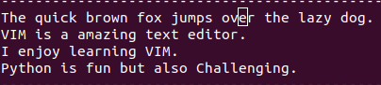

(iii) Correct punctuation errors in lines 10-13.
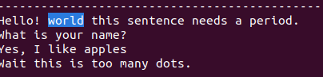

(iv) Remove unwanted words in lines 15-17.
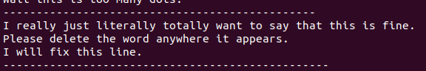
(v) Fix alignment issues in lines 19-22

